TECHNICAL PROTOCOL

Bilateral Comparison between
the High Voltage Transformer Measuring Systems
of TÜBİTAK UME and PTB

Pilot Lab: | Co-author:
Burak AYHAN | Peter Raether
TÜBİTAK UME | PTB

(Rev. 01)
December 03, 2019

Contents

1. Introduction 3
2. Travelling Standard 3
2.1. Description of Travelling Standard 3
2.2. Quantities to be Measured 4
2.3. Calculating the Reference Value 4
3. Participant Laboratories 4
4. Time Schedule 5
5. Transportation of Travelling Standard 5
6. Failure of Travelling Standard 6
7. Financial aspects 6
8. Measurement Quantities and Points 6
9. Measurement Instructions 8
9.1. Tests before Measurements 8
9.2. Measurements 8
10. Measurement Uncertainty 8
11. Reporting of Results 8
12. Final Report of the Comparison 9
13. References 9

Introduction
Bilateral comparison was planned to verify TÜBİTAK UME’s new High Voltage Transformer Measuring System which was developed within in the frame of the project of “Design of Reference Voltage Transformer and Ensuring Traceability of High Voltage Ratio and Phase Measurements to National Standards”.
UME is acting as the pilot institute. The travelling standard will be provided by TÜBİTAK UME. TÜBİTAK UME will be responsible to monitoring standard performance during the circulation and the evaluation and reporting of the comparison results.
The comparison will be carried out in accordance with the CCEM Guidelines for Planning, Organizing, Conducting and Reporting Key, Supplementary and Pilot Comparisons [1].

Travelling Standard

Description of Travelling Standard
The travelling standard will be a multi-ratio voltage transformer with rated primary voltages from 3 kV to 33 kV, secondary voltages of 100 V, 110V, 120 V, 100 / √3 V, 110 / √3 V, 120 / √3 V, rated burden of 3 VA. The nominal operating frequency of the standard is 50 Hz.
The cast resin travelling standard was manufactured by EPRO with the model of NVRD 40 and the serial number of 2/14/1189.
The travelling standard will be shipped in a custom built transportation case with dimensions 91 cm × 57 cm × 48 cm. The weight of the instrument transformer alone is 221 kg. The weight of the packed travelling standard in its case is 256 kg (the case being 35 kg).

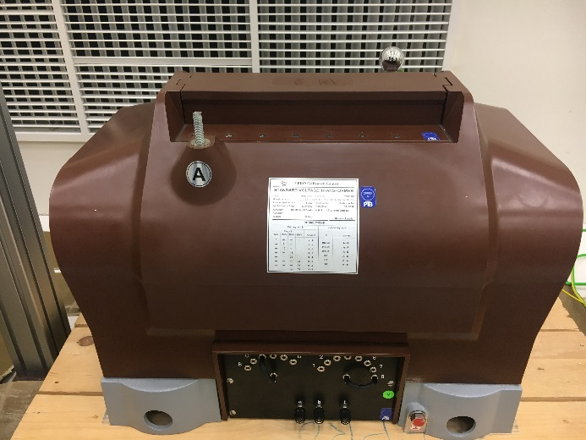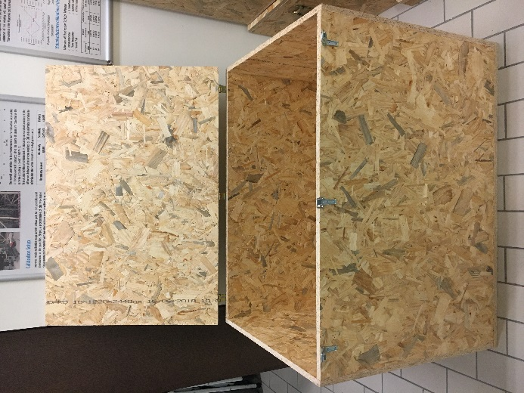
Figure 1 Travelling standard and transportation case

Quantities to be Measured
The quantities to be measured are the voltage error $ε_{u}$ (preferably in %) and the phase displacement $δ_{u}$ (preferably in crad) of the travelling standard for each of its rated transformation ratios and for a number of excitation voltages expressed as a percentage of rated primary voltage. The voltage error is defined as the error which a transformer introduces into the measurement of a voltage and which arises when the actual transformation ratio is not equal to the rated transformation ratio. The voltage error $ε_{u}$ is given by the formula:
$$ε_{u}=\frac{K_{n}U_{s}-U_{p}}{U_{p}}$$
where $U_{p}$ is the actual primary voltage, and $U_{s}$ is the actual secondary voltage when $U_{p}$ is applied under the conditions of measurement. The rated transformation ratio $K_{n}$ is
$$K_{n}=\frac{U_{p,r}}{U_{s,r}}$$
where $U_{p,r}$ is the rated primary voltage, and $U_{s,r}$ is the rated secondary voltage. The phase displacement $δ_{u}$ is defined as the difference in phase between the primary voltage and the secondary voltage vectors, the direction of the vectors being chosen so that the angle is zero for a perfect transformer. The phase displacement is said to be positive when the secondary voltage vector leads the primary voltage vector.
Appendix I contains details of the measurement points.

Calculating the Reference Value
The reference value and associated uncertainty for each test point will be a weighted mean and weighted uncertainty, respectively, calculated from the results of two participating laboratories. The instrument transformer shall also be measured by TÜBİTAK UME prior to shipment to PTB and on its immediate return from PTB, and an additional component of uncertainty will be applied for the stability of the instrument transformer derived from the spread of those results.

Participant Laboratories
The pilot institute for this comparison is TÜBİTAK UME (Turkey). The contact details of the coordinator are given in Table 1. The participating institutes and contact persons with their addresses are given in Table 2.
Table 1 Pilot Institute
Pilot Institute : | TÜBİTAK Ulusal Metroloji Enstitüsü (UME)
Coordinator : | Burak AYHAN  Tel: +90 262 679 50 00  Fax: +90 262 679 50 01  E-mail: burak.ayhan@tubitak.gov.tr

Table 2 Participants
Country | Institute | Acronym | Shipping Address | Contact Person
Turkey | TÜBİTAK  Ulusal Metroloji Enstitüsü | TÜBİTAK UME | TÜBİTAK Ulusal Metroloji Enstitüsü (UME)  TÜBİTAK Gebze Yerleşkesi  Barış Mah. Dr. Zeki Acar Cad. No:1  41470 Gebze-Kocaeli, TURKEY | Burak AYHAN  burak.ayhan@tubitak.gov.tr  Tel: +90 262 679 50 00
Germany | Physikalisch-Technische Bundesanstalt | PTB | Physikalisch-Technische Bundesanstalt (PTB) Bundesallee 100 38116 Braunschweig - Germany | Peter Raether  Tel: +49(531)-592-2339  Fax: +49(531)-592-69 2339 Email: Peter.Raether@ptb.de

Time Schedule
The time schedule for the comparison is given in the Table 3. The comparison will be organized in a single loop of two laboratories in order to allow close monitoring of the behaviour of the standard. Each laboratory will have 4 weeks to carry out the measurements and transportation. Any deviation in the agreed plan should be approved by the pilot institute.
Table 3 Circulation Time Schedule
Acronym of Institute | Country | Starting Date | Time for measurement and transportation
TÜBİTAK UME | Turkey | March, 2020 | 2 weeks
PTB | Germany | April, 2020 | 4 weeks
TÜBİTAK UME | Turkey | May 2020 | 2 weeks

Transportation of Travelling Standard
The instrument transformer standard will be transported with an ATA Carnet for customs clearance. The participants are responsible for arranging transport and insurance from their institute to the next participant. The instrument transformer standard can be shipped as freight. Extreme temperatures, pressure and humidity changes as well as violent impacts should be avoided.
After arrival in the participant’s laboratory, the standard should be allowed to stabilize in a temperature and possibly, humidity controlled room for at least one day before use.

Failure of Travelling Standard
In case of any damage or malfunction of the travelling standard in any way during operation, TÜBİTAK UME must be notified immediately and then the comparison will be carried out after the travelling standard is repaired.

Financial aspects
Each participant institute is responsible for its own costs for the measurements as well as any damage that may occur within its country.
The overall costs for the organization of the comparison are covered by the pilot institute. The pilot institute has no insurance for any loss or damage of the travelling standard.

Measurement Quantities and Points
The quantities to be measured and the measurement points are given in Table 4.

Table 4 Rated Transformation Ratio: 3000/100
Primary Voltage  (% of rated) | Rated Transformation Ratio: 3 kV / 100 V
 | Burden: 3VA |  | Measurement Uncertainty
 | Voltage Error (%) | Phase Displacement (crad) | (%) | (crad) | Coverage  Factor
40
60
80
100
120

Table 5 Rated Transformation Ratio: 6000/100
Primary Voltage  (% of rated) | Rated Transformation Ratio: 6 kV / 100 V
 | Burden: 3VA |  | Measurement Uncertainty
 | Voltage Error (%) | Phase Displacement (crad) | (%) | (crad) | Coverage  Factor
40
60
80
100
120

Table 6 Rated Transformation Ratio: 10000/100
Primary Voltage  (% of rated) | Rated Transformation Ratio: 10 kV / 100 V
 | Burden: 3VA |  | Measurement Uncertainty
 | Voltage Error (%) | Phase Displacement (crad) | (%) | (crad) | Coverage  Factor
40
60
80
100
120

Table 7 Rated Transformation Ratio: 20000/100
Primary Voltage  (% of rated) | Rated Transformation Ratio: 20 kV / 100 V
 | Burden: 3VA |  | Measurement Uncertainty
 | Voltage Error (%) | Phase Displacement (crad) | (%) | (crad) | Coverage  Factor
40
60
80
100
120

Table 8 Rated Transformation Ratio: 30000/100
Primary Voltage  (% of rated) | Rated Transformation Ratio: 30 kV / 100 V
 | Burden: 3VA |  | Measurement Uncertainty
 | Voltage Error (%) | Phase Displacement (crad) | (%) | (crad) | Coverage  Factor
40
60
80
100
120
Also the quantities given below must be measured;
- Ambient temperature
- Ambient humidity
No correction will be applied for the ambient temperature and relative humidity.

Measurement Instructions

Tests before Measurements
Visual inspection for damage to the cast resin case of travelling standard, terminals and insulators that may have occurred in transport.
DC winding resistance checks should be performed to ensure the integrity of the internal connections and coils. TÜBİTAK UME will supply typical values for comparison. Beware of the possible magnetisation of the magnetic core due to this test.

Measurements
The environmental conditions (temperature and humidity) during the measurements must be recorded. The recommended conditions are (20 to 23) °C ± 2 °C with a maximum of 65 % rh
The terminals marked “B”, “b” and “⊥” should be earthed to the measurement ground during the comparison measurements.
The supply frequency for all measurements is 50 Hz ± 0.5 Hz with a sinusoidal waveform

Measurement Uncertainty
The uncertainty of measurement must be calculated according to the JCGM 100 “Guide to the Expression of Uncertainty in Measurement” [2] for the coverage probability of approximately 95%.
All contributions to the measurement uncertainty should be listed in the report submitted by each participant. Even though the contributions to the uncertainty are specific to the measurement method used, it may be useful to consider the list of uncertainty sources given below.
- Type A
- Calibration of bridge and comparator
- Error in the bridge
- Error due to frequency setting
- Error due to burden setting
- Error due to temperature
- Circuit configuration
- Error due to voltage setting
This is not a complete list and should be extended with uncertainty contributions that are specific for the participant’s measurement system.

Reporting of Results
The results should be communicated to the pilot institute within 30 days of completing the measurements.
The participant shall report their results using the standard certificate that they would normally issue to a customer. However, results shall also be reported in the pilot institute. The report must contain at least:
- Details of participating institute,
- The date and time of the measurements,
- A detailed description of the method used,
- The measurement standards used in the comparison measurements,
- Software used in the comparison measurements
- The environmental conditions during the measurements;
  - ambient temperature
  - relative humidity
- Results of measurement; The measurement results shall be provided according to Table 4 - 8
- A statement of traceability,
- The Type A standard uncertainty;
- Detailed uncertainty budget with the different sources of uncertainty and their values, as;
- Expanded measurement uncertainty, estimated for the coverage probability of approximately 95%.

Final Report of the Comparison
The pilot institute is responsible for the preparation of a comparison report.
The draft version of the comparison report will be issued within two months after receiving the participant report by the pilot institute. Draft report will be sent to the PTB for discussion and approval. This draft will be confidential to the participants.
The participant will have one week to send their comments on Draft Report. After approval, Draft Report will become the Final Report. The Final Report will form the basis for the publication of results.

References
- CCEM Guidelines for Planning, Organizing, Conducting and Reporting Key, Supplementary and Pilot Comparisons, 2007 (available on the BIPM website: http://www.bipm.org/utils/common/pdf/CC/CCEM/ccem_guidelines.pdf)
- Evaluation of measurement data - Guide to the Expression of Uncertainty in Measurement (GUM), JCGM 100, First edition, September 2008 (available on the BIPM website: http://www.bipm.org/utils/common/documents/jcgm/JCGM_100_2008_E.pdf)

